Dim’3 portfolio in Baxter strategy

ENHANCE CLINICAL DECISIONS PROCESSES  Dim3 , a platform adapted to various medical sectors | ENHANCE CLINICAL DECISIONS PROCESSES IN CLINICAL NUTRITION  CE marked ready to market  Clinical Nutrition Platform
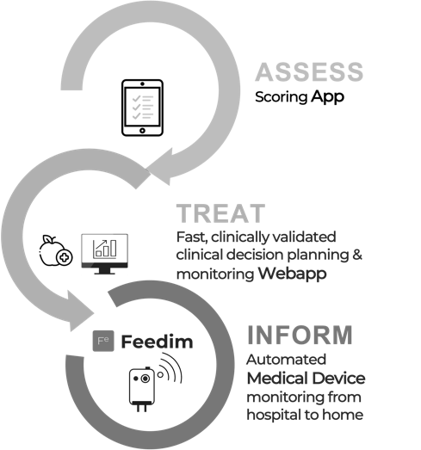 | 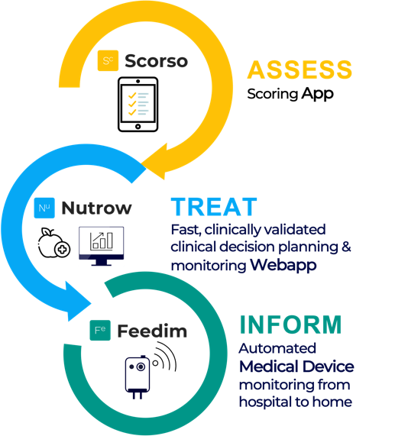
INTRODUCTION
Dim3 products can be useful to maintain or manage current and future Baxter Portfolio in the field of a new digital clinical decision tools approach. Dim3 does not only aggregates all available data but increase their potential by providing them a clinical decision leverage environment and impact on reimbursement.
Beside or embedded in Baxter’s home solutions, Dim3 adds a versatile data connected platform to increase efficiency of clinical decision processes in all Baxter divisions using Medical Devices. The most important novelty is the clinical decision potential in all the patient pathway, from hospital to homecare and vice versa. This fit with the requirement of the reorganization of healthcare policies to lower hospital costs by stimulating Homecare and Hospital at Home proposals.
Even with medical devices already able to transmit data, Dim3 platform provides missing links in real-life data transmission and use in healthcare structures.
Sales of Healthcare products are dependent, in part, on the availability of reimbursement by government agencies and healthcare programs, as well as insurance companies and other private payers . Dim3’s platform and impact on reimbursement in some European countries could be a seed product to provide to customers reimbursement leverage digital package

With the Dim3’s platform using Nutrow as a command center for clinical decision, Baxter increases its footprint in the market by providing a digital solution that gives immediate technical, scientific and commercial assets for Clinical Nutrition unit and can be considered as a digital frame for other divisions.
Partnering with Dim3 is orientating Baxter investments to drive innovation in digital product areas with a compelling opportunity to serve patients and healthcare professionals while advancing business and accelerating the pace in which Baxter brings these advances to market.
DIM3 PLATFORM INSERTION IN BAXTER’s CATALOG

The center of gravity of Dim3 platform is the digital solution Nutrow able to aggregates all data available in the customer environment.

When already available, the data of Medical Devices data are pushed in Nutrow to ease the clinical decision processes. In many situations and even with Medical Devices technically able to transmit data , the instruments are not “data connected”. This loss of information hampers strongly the quality of clinical decision. This is where Feedim is the missing link and allows full Nutrow potential.

Usually, Medtech products of a company can be classified in 4 categories with a potential use of the Dim3 product Feedim to grab data and feed Nutrow.

CATEGORY | CONNECTIVITY COMMENTS | FEEDIM
Installed base | - Poorly or Not conceived for connectivity or obsolete connectivity | 
Refurbishing Medical Devices. | - Poorly or Not conceived for connectivity or obsolete connectivity
Medical devices developed and produced by Baxter itself | - Medical Devices with FDA/CE data connexion with a Baxter in-house protocol to be validated by authorities and hack protected at its maximum  - Connectable device does not means that they are really connected in real-life
Medical devices developed and produced by third parties with a commercial partnership (ex: Cosmed in Clinical Nutrition) | - Medical Devices with FDA/CE data connexion with a non Baxter in-house protocol to be validated by authorities and hack protected at its maximum  - Connectable device does not means that they are really connected in real-life  - Medical Devices not connectable

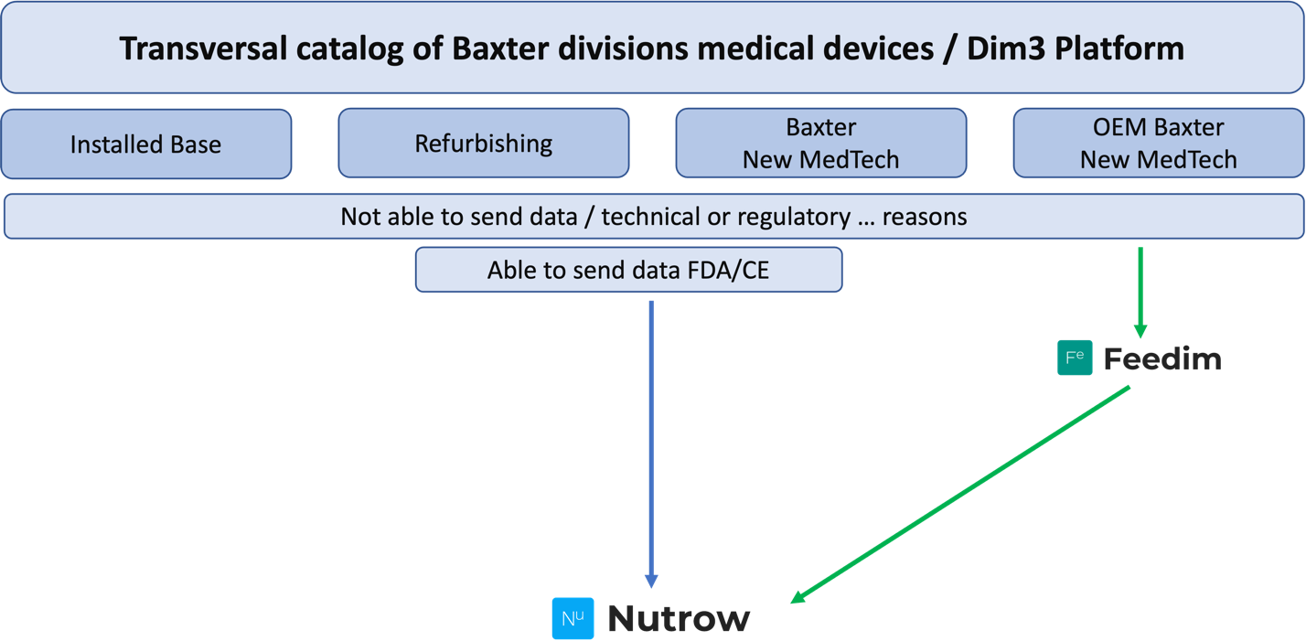
Looking at trends in healthcare, one is strongly modifying the strategic approach of Medtech companies: the limitations of stays in hospital. This is a worldwide trend with major speed adoption in Europe.

The trend generates new market opportunities for Homecare, Hospital at home, patient and family awareness, reimbursement impacts products and services

This evolution is accompanied by a complexity in data transmission and management due to the diversity of situations. It is where the Dim3 platform plays its major function: whatsoever the patient pathway and location, data are always actionable to take clinical decisions. This is a breakthrough as healthcare companies have focused their efforts mainly on hospital solutions. Being independent of the infrastructure environment, Dim3 platform is placed at the right place and moment.

The following figures show that even with existing Medical Devices able to communicate, in situation as Homecare or hospital at home the existing data transmission model may add for outside hospital situation the Feedim solution

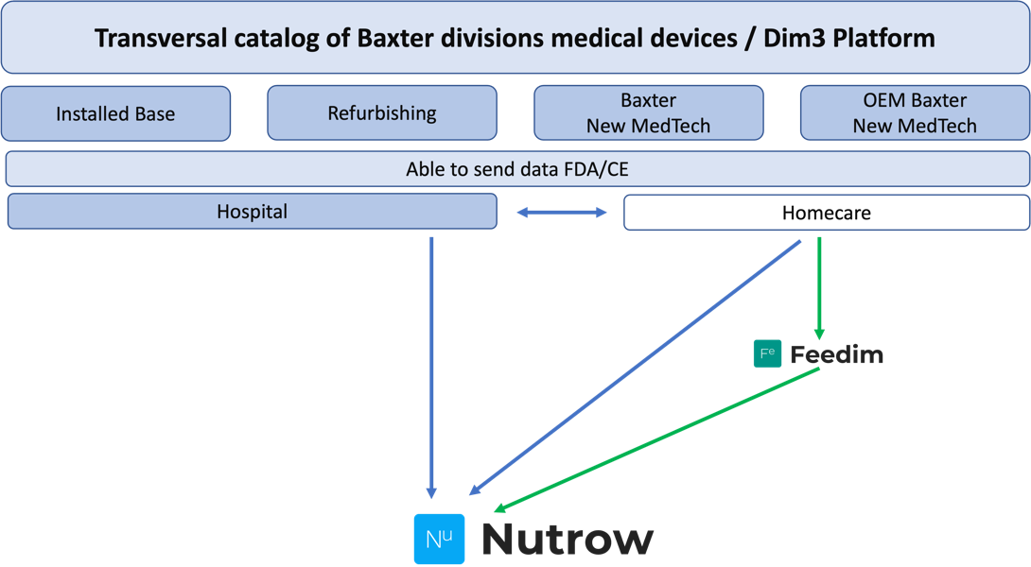

Conclusion :

The platform of Dim3 has been conceived to work in different diseases management. That means that the architecture of this platform can be adapted to other situation than Clinical Nutrition. Many divisions of Baxter can adapt and adopt this platform embedded or not in the existing digital solutions of Baxter.

The platform of Dim3 has been conceived to work in all the patient pathway. That means that data to take clinical decisions are actionable every time and everywhere.

With the Feedim device, the platform of Dim3 fills a gap in data transmission of Medical Devices. The potential to use medical devices data multiply the efficiency of the platform in terms of quality of clinical decision. Feedim can be connected to the majority of Medical Devices with an existing connecting port. That means that global Baxter can use the Dim3 platform including Feedim in real-life situation where Medical Device are not connectable for reasons beyond technics.

Dim3 platform opens sales opportunities not seen before by aggregating data, given to them a clinical value in all Baxter Divisions and providing solutions to many stakeholders including reimbursement one.

